ALGEBRA FOR CALCULUS

STRETCH I FINAL REVIEW SHEET *ANSWERS Sp 15*

1. a) F; ;



b) F; ; 

c) F; ; 

d) NF; ; 

e) F; ; 

2. a) 

b) 

c) 

d) 3 values: 

3. a) 

b) 

c) 

d) 

e) 

f) 

4. a) , 

b) 

c) 

5. a) D: ; R:

b) D: ; R: 

c) D: ; R:

6. $ 161.4 million per year

7. 

8a) 

8b) 

9. 

10. 

11. 

12. a) 

b) 4

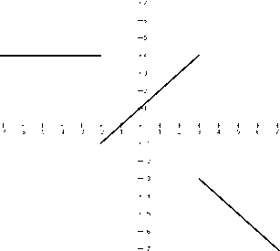 c) 3.5

13.

14. a) Increasing: 

b) Decreasing: 

c) Constant: 

15. a) 

b) Domain: 

16. a) 

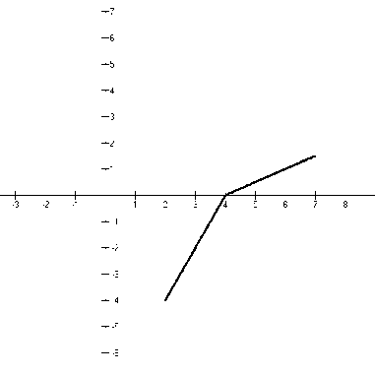 b)

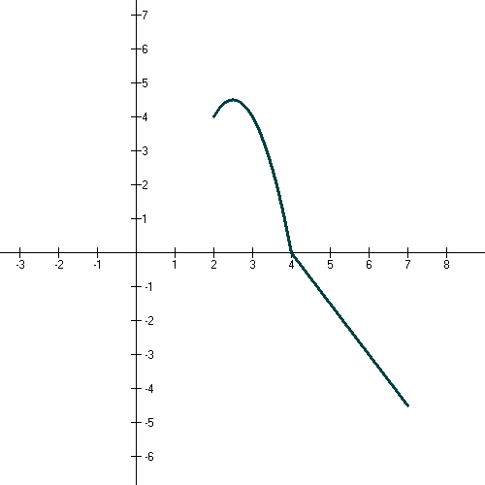

c)

17. a) 

b) 

24. a)  b) 

25. a) 

b) 

c) 

d) 

26. a) 

b) 

27. 

a) vertex: 

b) axis of symmetry: 

c) Since the leading coefficient is

positive, the function has a

minimum. The minimum value

is 

28. a) seconds

b) Max height is ft.

29. odd

30.

|  |  |  |
| --- | --- | --- |
| ***Zeros*** | ***Mult*** | ***at x-axis*** |
| 0 | 3 | cross |
| -3 | 2 | tangent |
| 4 | 1 | cross |
| -1 | 4 | tangent |

31.

|  |  |  |
| --- | --- | --- |
| ***Zeros*** | ***Mult*** | ***at x-axis*** |
| 1 | 1 | cross |
| -2 | 2 | tangent |
| 2 | 1 | cross |

***End behavior:***

(degree is even and leading coefficient is negative, so think about  reflected about x-axis)

As 

As 

|  |  |  |
| --- | --- | --- |
| ***Intervals*** | ***Test value*** | ***or*** |
|  |  |  |
|  |  |  |
|  |  |  |
|  |  |  |

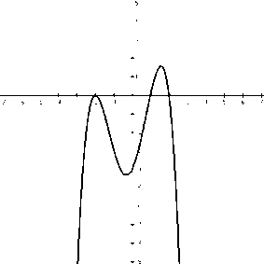

32. Quotient: 

Remainder: 

33. 

Not a factor

34. a) 

b) 

35. a) 

b) 

c) 

d)  

e) 

36. a) 

 

b) 

c) 

39. a) 

b) 

c) 



b)

c)

63. 225

64. a) 

b) 

65. a) 

b) 

66. 

67. 

68. 

69. 

70. 136 marchers

71. a) 6561

b) 96

c) 

d)

72. 

73. a) 

b)

c) Does not exist

74.

75. a) ft

b) Approximately

(1705/256 ft about 6.660 ft )

76. x = 17, x = -7

77. a) (-11/2,25/2)

b) (-∞, -6/5} {24/5,∞)

c) no solution

d) all real numbers, (-∞,∞)

78. See Exam I and MyLabsPlus