4. Find the domain of each of the following:

a) 

b) 

c) 

d) 

e) 

5. Find the domain and range of each of the

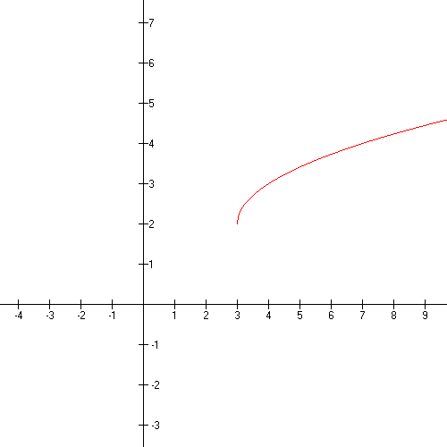 functions represented by the following graphs.

a)

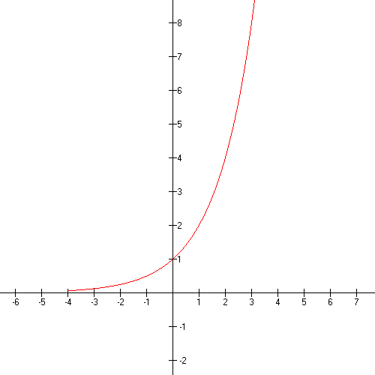 b)

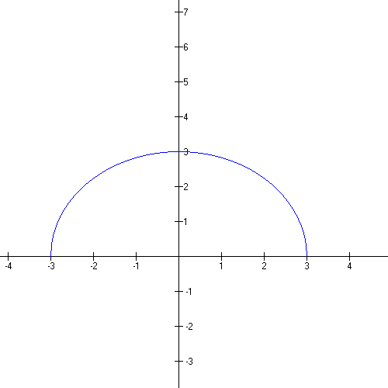

c)

18. Given the functions *f* and *g* defined by the following:  and.

a) Find the domain of *f* + *g*

b) Find *f* + *g.*

c) See more rational expressions exam III

19. Forand 

a) Find  and 

b) Find the domain of  and .

20. Given that  and , find  and .

21. Determine whether the graph of  is symmetric with respect to the *x-*axis, the *y-*axis, or origin.

22. Test algebraically whether the following functions are even, odd, or neither.

a) 

b) 

c) 

23. Write an equation for a function that has the shape of

a)  but shifted right 2 units and down 3

units.

b)  but stretched vertically by a factor of 2

reflected through the *x-* axis and shifted up 5.

c)  but shrunk horizontally by a factor of 3

and shifted up 2 units.

37. Name the vertical and horizontal asymptotes of

the following rational functions.

a) 

b) 

c) 

d) 

38. Find the zeros of each of the functions in # 37.

39. Solve each of the following inequalities:

d) 

e) 

40. Which of the following functions are

one-to-one?

a)  b) 

c)  d) 

41. Findfor each of these.

a) 

b) 

c) 

42. Verify that  and  are inverses of each other by using composition of functions.

43. Sketch the inverse of the function represented

by each graph below.

a)



b)

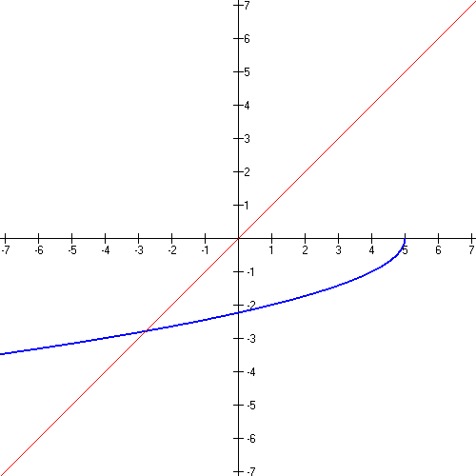

44. Without using your graphing calculator, sketch a graph of each of these.

a) 

b) 

c) 

45. How much money will be in an account in 20 years if it compounds 7.5% interest quarterly and you deposit $5,000 now?

46. Evaluate each of these.

a) 

b) 

c) 

d) 

e) 

47. Sketch an accurate graph of . Name the domain, range, intercept, asymptote.

48. Express in terms of sums and differences of logarithms.

a)  b)  c) 

49. Write as a single logarithm: 

50. Simplify

a)  b)  c) 

51. Solve each of these.

a) 

b) 

c) 

d) 

e) 

52. The population of a country doubled in 8 years. What was the exponential growth rate?

53. Suppose $8,000 is invested at rate *k*, compounded continuously, and grows to $11,466.64 in 6 years.

a) Find the interest rate

b) Find the exponential growth function.

c) Find the balance after 10 years.

d) Find the doubling time.

54. Average cell phone prices have fallen sharply since their introduction to the market in 1983. In 1984, the average price was $3395, and in 2002, it was only $145. Assuming the average price of a cell phone decreased according to the exponential model:

a) Find the value of *k* and write an exponential function that describes the average price of a cell phone after time *t,* in years, where *t* is the number of years since 1984.

b) Estimate the price of a cell phone in 2004.

c) At what time *t* was the price half the original price?

55. Find the distance and midpoint between each pair

of points.

A) 

B) 

56. Find the vertex, focus, and directrix, then sketch each parabola:

1. 
2. 
3. 

57. Find the center and radius of the circle:

a)

b) 

c) 

58. Find the center, vertices, and the foci of each ellipse. Then sketch the graph.

1. 
2. 
3. 
4. 

59 . Find the center, vertices, and the foci of each

hyperbola . Then sketch the graph.

1. 
2. 
3. 
4. 

60. Classify each of the following as a parabola,

circle, ellipse, or hyperbola. Explain your

reasoning.

1. 
2. 
3. 
4. 
5. 
6. 

61. A spotlight has a parabolic cross section that is 6 ft wide at the opening and 4.5 ft deep at the vertex. How far is the focus from the vertex?

62. A carpenter is cutting a 3 ft by 4 ft elliptical sign from a 3 ft by 4 ft piece of plywood. The ellipse will be drawn using a string attached at the foci of the ellipse. How far from the ends of the board should the string be attached?



79. Find the equation of a circle satisfying the given

condtions.

a) Center (4,5) diameter of length 8.2

b) Center (-1,4) passes through (3,7)

c) The points (7,13) and (-3,-11) are at the ends of

a diameter.

d) Center (-2,3) tangent to the y-axis.

80. For topics on rational expressions see Exam 3 from the intermediate algebra text chapter 5 sections 5.1-5.2, 5.4-5.6 I.A. and MyLabsPlus Software.